**PC Assemble (22 November 2023)**

Step for PC reassemble:

1. Open Case
2. Disconnect cable
3. Take out power supply
4. Take out RAM
5. Take out HDD
6. Take out CPU fan

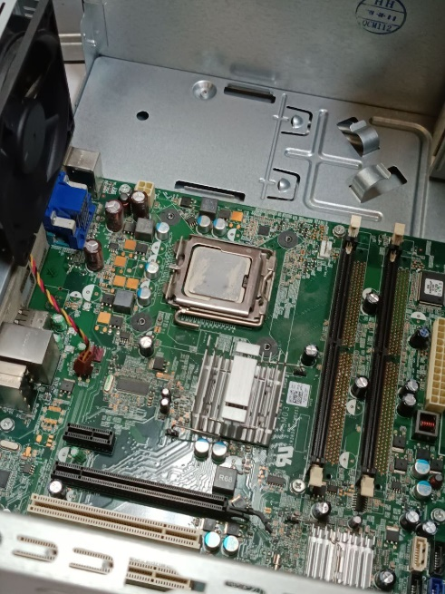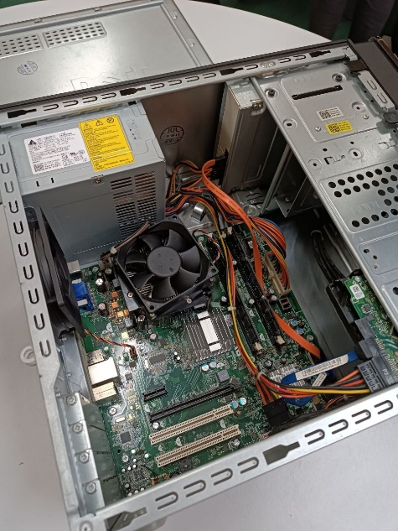Photo and Video:

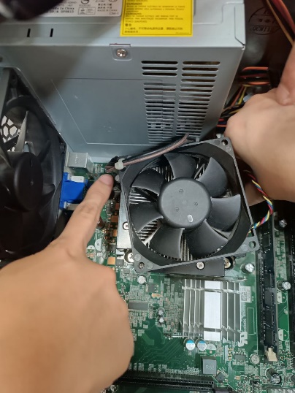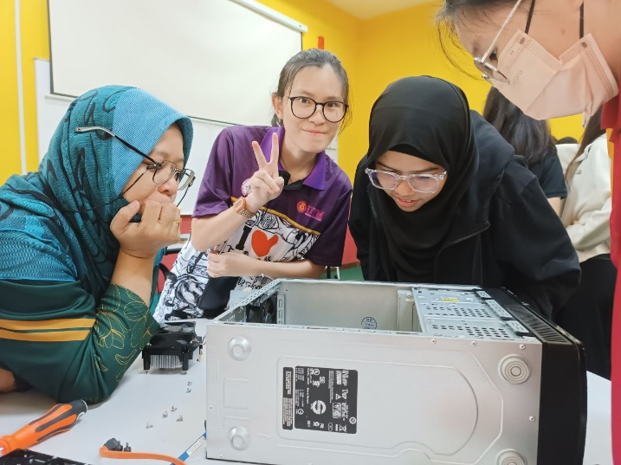

Reflection:

Through PC Assemble:

* I learned how to properly reassemble a computer and assembly it back together.
* I learned more about the parts inside a computer and their functions.
* The tacit understanding between me and the team members has increased. After listening to the explanation, everyone had the opportunity to do hand on and quickly perform each different step. In the end, our cooperation makes us the fastest team complete the assembly task in the class.